QUOTE QUICKLY

**At the outset**, X **establishes** __ by using a ___tone in phrases like **“__” and “__.”**

**“__” and “__” in line_ also illustrate __.**



**Additionally**, **to reinforce** __, X uses **DEVICE** in “_,” “_,” and “_.”

**However**, the strongest statement was “… _____” as it **exaggerates** __.

*He concludes his intro by __ “__” and “__****,****”* ***suggesting*** *___.*

**IN-Text Citations**

In 2017, **Source argued “______.”**

According to **data in 2009,**

**Source reveals** __.

In the **Journal** “__,” **author** __ **details how “**__” **(2009).**

The **website** “**SourceName.gov**” **describes “**_ .**”**

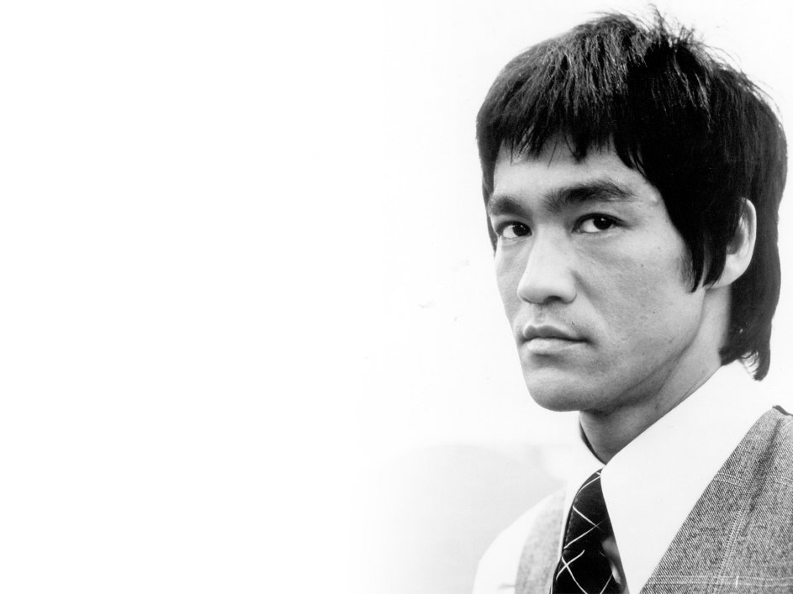Historical **evidence** **describes** __ (**Source 2007**).

Recent **studies** (2016)

**show** _ (**Last Name**).

2005 **statistics** of __

**reveal** (**Last Name**).