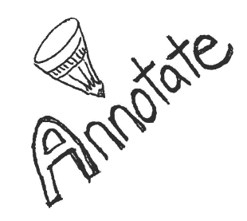

Ex-Basketball Player

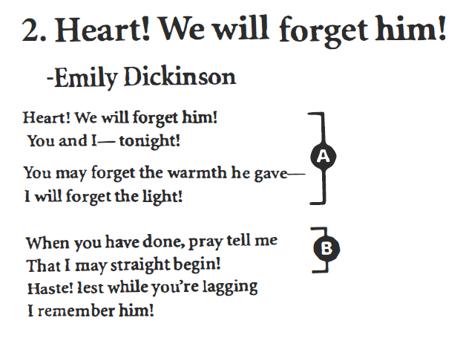

***2. Heart!***

***We Will Forget Him!***

***3.***

*John Updike*

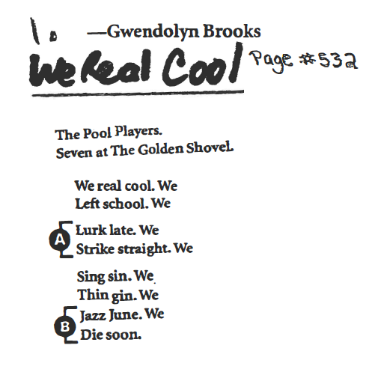

***1.***

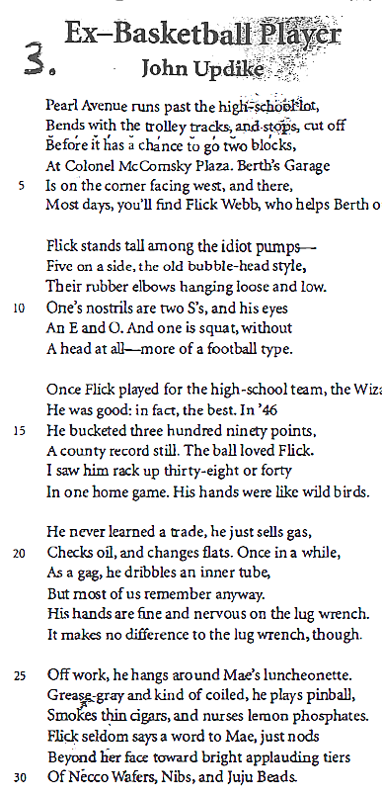

**Pg.532**

*By Gwendelyn Brooks*



In 2 sentences, summarize Brook’s purpose (try to use effects verbs):

**NOW IT IS YOUR TURN!** Write a Poem about a Natural Disaster or Phenomena (you can make it literal or symbolic).

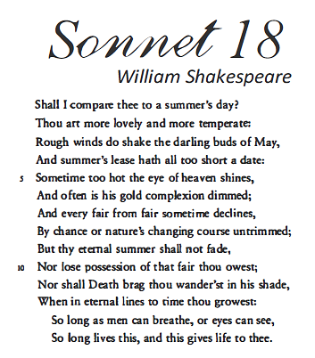

***5.***

***4.***

*Those Winter Sundays*

*By Robert Hayden*

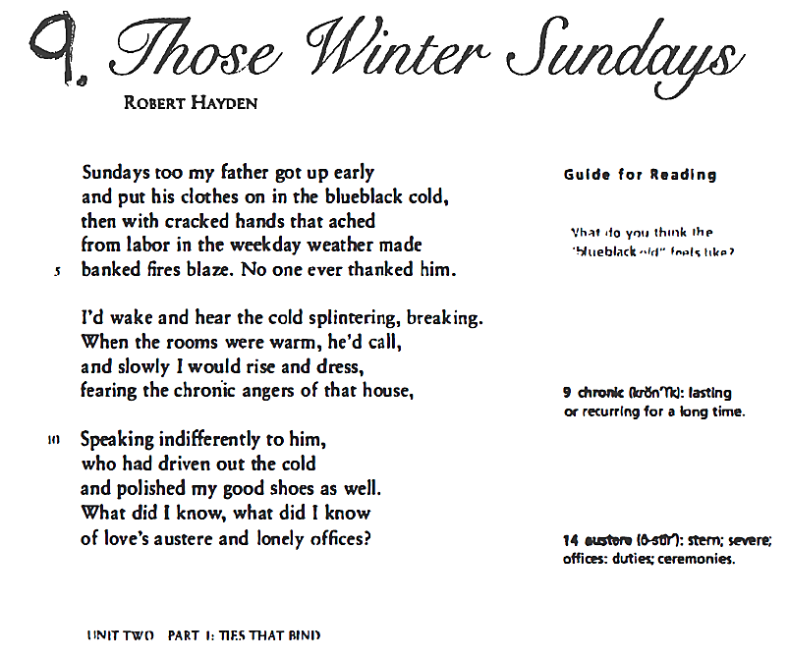

Precis:

Precis:

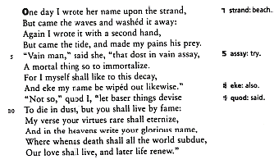

***7.***

Edna St. Vincent Millay

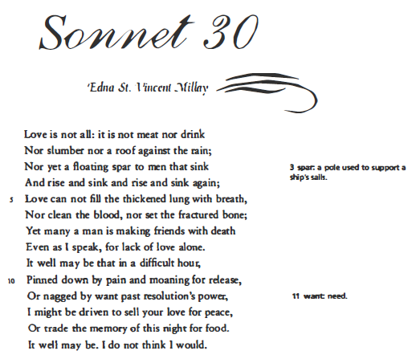

***30***

*Edmund Spenser*

***SONNET 75***

***6.***

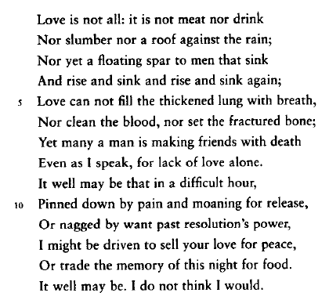

Compare Precis:

10. Jabberwocky-

By Lewis Carroll

‘Twas brillig, and the slithy toves

Did gyre and gimble in the wabe;

All mimsy were the borogoves,

4 And the mome raths outgrabe.

"Beware the Jabberwock, my son

The jaws that bite, the claws that catch!

Beware the Jubjub bird, and shun

8 The frumious Bandersnatch!"

He took his vorpal sword in hand;

Long time the manxome foe he sought—

So rested he by the Tumtum tree,

12 And stood awhile in thought.

And, as in uffish thought he stood,

The Jabberwock, with eyes of flame,

Came whiffling through the tulgey wood,

16 And burbled as it came!

One, two! One, two! And through & through

The vorpal blade went snicker-snack!

He left it dead, and with its head

20 He went galumphing back.

"And hast thou slain the Jabberwock?

Come to my arms, my beamish boy!

O frabjous day! Callooh! Callay!"

24 He chortled in his joy.

'Twas brillig, and the slithy toves

Did gyre and gimble in the wabe;

All mimsy were the borogoves,

28 And the mome raths outgrabe.

**9. Fire and Ice**

**by Robert Frost**

Some say the world will end in fire;

some say in ice.

From what I've tasted of desire

I hold with those who favor fire.

But if it had to perish twice,

I think I know enough of hate

to know that for destruction ice

is also great and would suffice.

**8. WHAT IS CINCO DE MAYO**

by [Angela Ivanovskiy](http://contributor.yahoo.com/user/1555022/angela_ivanovskiy.html)

Just what is Cinco de Mayo?  Let us start with what it is not.

It has nothing to do with Spain, though that is what many have thought.

Mexico got its freedom from  Spain in September 1810,

When independence did come to  Mexican kids, women and men.

During the US Civil War  Mexico was battling too.

This time it was against the French  On May fifth 1862.

Napoleon the third was sent  By France to conquer Mexico.

His army was stronger and so  Victory would be his, but no.

The Mexican army was small,  Outnumbered nearly two to one.

General Zaragoza led  His Mexican troops, and they won.

The battle took place in Puebla,  And the French were hurt & withdrew.

 Today Mexicans as well as  Americans honor that crew.

Celebrations far and wide are  Held, with dancing, parties, parades,

 Dining, drinking & toasting those numbered small but were so brave.

[Cinco de Mayo](http://voices.yahoo.com/topic/118497/cinco_de_mayo_2009.html) is its name  In most of the Americas,

But it is better known as El Dia  De la Batalla de Puebla.

That is in Spanish for The Day  Of the Battle of Puebla, and

Many cultures are united  Due to Mexico's mighty stand.

So this May when you are with friends  Partying, tell them you know

 What it is about, and then tell  Them about Cinco de Mayo!

***9.***

**11. Dreams**

**by Langston Hughes**

Hold fast to dreams  
For if dreams die  
Life is a broken-winged bird  
That cannot fly.

Hold fast to dreams  
For when dreams go  
Life is a barren field  
Frozen with snow.

Precis:

**12. If By Rudyard Kipling**

If you can keep your head when all about you   
Are losing theirs and blaming it on you;   
If you can trust yourself when all men doubt you,   
But make allowance for their doubting too;

If you can wait and not be tired by waiting,   
Or, being lied about, don't deal in lies,   
Or, being hated, don't give way to hating,   
And yet don't look too good, nor talk too wise;

If you can dream & not make dreams your master;   
If you can think - and not make thoughts your aim;   
If you can meet with triumph and disaster   
And treat those two imposters just the same;

If you can bear to hear the truth you've spoken   
Twisted by knaves to make a trap for fools,   
Or watch the things you gave your life to broken,   
And stoop and build 'em up with wornout tools;

**13. The Lord is My Shepherd**

**Psalm 23 - By King David**

*1* The Lord *is* my shepherd;  
 I shall not want.  
**2**He makes me to lie down in green pastures; He leads me beside the still waters.

**3**He restores my soul;

He leads me in the paths of righteousness  
For His name’s sake.

**4**Yea, though I walk through the valley of the shadow of death, I will fear no evil;  
For You *are* with me;  
Your rod and Your staff, they comfort me.

**5**You prepare a table before me in the presence of my enemies;  
You anoint my head with oil;  
My cup runs over.

**6**Surely goodness and mercy shall follow me All the days of my life;  
And I will dwell[[a](https://www.biblegateway.com/passage/?search=ps+23&version=NKJV#fen-NKJV-14242a)] in the house of the Lord Forever.

*NKJV*

If you can force your heart and nerve and sinew   
To serve your turn long after they are gone,   
And so hold on when there is nothing in you   
Except the Will which says to them: "Hold on";

If you can talk with crowds and keep your virtue,   
Or walk with kings - nor lose the common touch;   
If neither foes nor loving friends can hurt you;   
If all men count with you, but none too much;

If you can fill the unforgiving minute   
With sixty seconds' worth of distance run -   
Yours is the Earth and everything that's in it,   
And - which is more - you'll be a Man my son!

Precis:

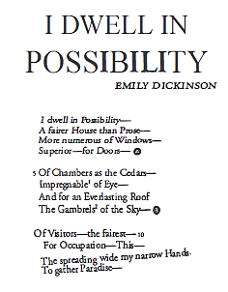

***14.***

***15.***

***16.***

**Sick**

"I cannot go to school today,"

Said little Peggy Ann McKay.

"I have the measles and the mumps,

A gash, a rash and purple bumps.

My mouth is wet, my throat is dry,

I'm going blind in my right eye.

My tonsils are as big as rocks,

I've counted sixteen chicken pox

And there's one more--that's seventeen,

And don't you think my face looks green?

My leg is cut--my eyes are blue—

It might be instamatic flu.

I cough and sneeze and gasp and choke,

I'm sure that my left leg is broke—

My hip hurts when I move my chin,

My belly button's caving in,

My back is wrenched, my ankle's sprained,

My 'pendix pains each time it rains.

My nose is cold, my toes are numb.

I have a sliver in my thumb.

My neck is stiff, my voice is weak,

I hardly whisper when I speak.

My tongue is filling up my mouth,

I think my hair is falling out.

My elbow's bent, my spine ain't straight,

My temperature is one-o-eight.

My brain is shrunk, I cannot hear,

There is a hole inside my ear.

I have a hangnail, and my heart is--what?

What's that? What's that you say?

You say today is. . .Saturday?

G'bye, I'm going out to play!"

**~ Shel Silverstein**

**School (Untitled)**

I begin each morning as I wake.  
It's a slew of classes today, I'll take.

I hop the bus and ride to school.  
Bags under my eyes make me look like a ghoul.

Georgia History is my first period class.  
I'll sleep it through and wait for it to pass.

I wake up just in time for reading.  
I'm late...on my forehead, sweat is beading.

It's this class that I'm really hating.  
Guess what! I left my teacher waiting.

I get a lecture and have to read.  
And for punishment, I have to do a stupid deed.

Banging erasers after class is what I am doing.  
The rest of my class is watching, wooing.

And off to media production, I run.  
I know that there, I'll have no fun.

That class ends and it's time for health.  
It's there I get education wealth.

Then the 5th period bell rings.  
It's time for algebra with numbers and things.

I get to the class a few minutes late.  
It's time for the number debate.

Everyone's problem has a different answer.  
I hate this class. I'd rather have cancer.

Finally, when I think I'll die,  
Algebra ends and to science I fly.

Oh, great!  
This is the teacher I hate!

After pulling my hair out and biting my lip,  
this class ends and to English I skip!

English ends and it's time to go home.  
I leave the class and the school halls I roam.

I get to my house and think I can lay down.  
I remember homework and put on a frown.

I finish my homework and head off to bed.  
I lay down and rest my head.

I think of how I'd love to just play.  
But, it's to school tomorrow for another grueling day.

**~ Ashley**

***17.***

**I'm Nobody! Who are You?**

**by Emily Dickinson 1830 - 1886**

I'm Nobody! Who are you?  
Are you -- Nobody -- Too?  
Then there's a pair of us!  
Don't tell! They'd advertise -- you know!  
  
How dreary to be Somebody!  
How public -- like a Frog --  
to tell one's name - the livelong June –

to an admiring Bog!

*Bog=swamp*

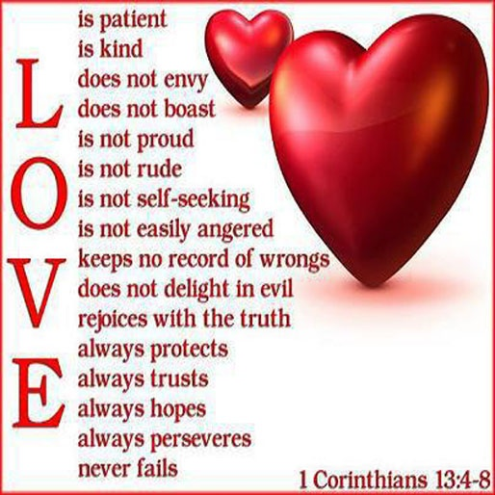

***16.***

I've Been A Victim Of A Selfish  
Kind Of Love  
It's Time That I Realize  
That There Are Some With No  
Home, Not A Nickel To Loan  
Could It Be Really Me,  
Pretending That They're Not  
Alone?  
  
A Widow Deeply Scarred,  
Somebody's Broken Heart  
And A Washed-Out Dream  
(Washed-Out Dream)  
They Follow The Pattern Of  
The Wind, Ya' See  
Cause They Got No Place  
To Be  
That's Why I'm Starting With Me  
(Starting With Me!)  
  
I'm Starting With The Man In  
The Mirror (Ooh!)  
I'm Asking Him To Change  
His Ways (Ooh!)  
And No Message Could Have  
Been Any Clearer  
If You Wanna Make The World  
A Better Place  
(If You Wanna Make The  
World A Better Place)  
Take A Look At Yourself And  
Then Make A Change  
(Take A Look At Yourself And  
Then Make A Change)

MAN IN THE MIRROR

- Michael Jackson

I'm Gonna Make A Change,  
For Once In My Life  
It's Gonna Feel Real Good,  
Gonna Make A Difference  
Gonna Make It Right . . .  
  
As I, Turn Up The Collar On My  
Favourite Winter Coat  
This Wind Is Blowin' My Mind  
I See The Kids In The Street,  
With Not Enough To Eat  
Who Am I, To Be Blind?  
Pretending Not To SeeTheir Needs  
A Summer's Disregard,  
A Broken Bottle Top  
And A One Man's Soul  
They Follow Each Other On  
The Wind Ya' Know  
'Cause They Got Nowhere To Go  
That's Why I Want You To Know  
  
I'm Starting With The Man In  
The Mirror  
I'm Asking Him To Change  
His Ways  
And No Message Could Have  
Been Any Clearer  
If You Wanna Make The World  
A Better Place  
(If You Wanna Make The  
World A Better Place)  
Take A Look At Yourself, And  
Then Make A Change  
(Take A Look At Yourself, And  
Then Make A Change)  
(Na Na Na, Na Na Na, Na Na,  
Na Nah)

Name__________________________________ per___

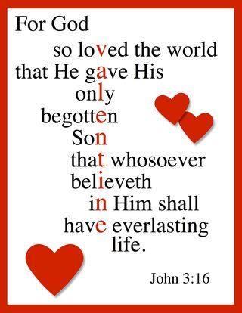

**ANNOTATE the song** (circle/ underline, or draw arrows and put notes on the side).Then compare it to Michael Jackson’s song, “Man in the Mirror.” Lastly, listen to both songs.

***[Hook]***[*You don't really know what you were put here for but before you go*](http://genius.com/1384664/Lecrae-change/You-dont-really-know-what-you-were-put-here-for-but-before-you-go) *You looking for a (change)  
You trying find a home you can call your own  
You way too grown to making that chump (change)  
Life's too short you been down too long  
You see them clothes it's time for them to (change)*

…*…*[*They say the Lord don't (change)*](http://genius.com/2223655/Lecrae-change/They-say-the-lord-dont-change)

*But the more things (change)  
The more they don't (change)  
But ya boy needs (change)*

[Verse 2]  
[Now you got Oprah on  
Thinking maybe she can help you out your hopeless zone (she gone change) you](http://genius.com/2056933/Lecrae-change/Now-you-got-oprah-on-thinking-maybe-she-can-help-you-out-your-hopeless-zone-she-gone-change-you)  
You even tried the church  
The pastor gave you bunch of rules they ain't seem to work you don't (change)

You tried another one though  
That got you feeling good inside and gotcha runnin' for more and more (change)  
But all about you  
[Not God not truth/ just because you wear the suit don't mean you been (changed)](http://genius.com/1450899/Lecrae-change/Not-god-not-truth-just-because-you-wear-the-suit-dont-mean-you-been-changed)  
[Christ is just a means to money  
Plus health](http://genius.com/2135409/Lecrae-change/Christ-is-just-a-means-to-money-plus-health) [You the master, he's the dummy](http://genius.com/2135412/Lecrae-change/You-the-master-hes-the-dummy) No (change)

Well if not that...  
Hen maybe it's better to be confused and forget all facts and all (change)  
Still been chasing the change  
And look where it got you depressed ain't a thang not you ain't making no (change)  
You tried to find God  
The horoscopes and stars still ain't getting very far so far no (change)

[He was hated, hurt, slandered and slain but his death brought (change)](http://genius.com/3300272/Lecrae-change/He-was-hated-hurt-slandered-and-slain-but-his-death-brought-change)  
Be a slave to your sin  
Hate God, love money, love lies, Christ died so you can (change)  
[It's kinda fun for a while  
But you'll lose that smile when your lights go out and the pain won't (change)](http://genius.com/3300276/Lecrae-change/Its-kinda-fun-for-a-while-but-youll-lose-that-smile-when-your-lights-go-out-and-the-pain-wont-change)  
  
[Outro]  
Yeah money, power, possessions  
Chasing all that stuff, and you're still not getting that  
That change inside you lookin for man  
Cause it won't satisfy  
You need to turn away from all that and turn to the cross of Jesus Christ  
He died to pay for all your sin  
Jesus

***(Hook)***

[Verse 3]  
What if life ain't supposed to be gravy  
Full of hurt, pain, death, rape, murder and craziness  
[If God made everything good  
Then why you still gotta live in the hood what's really good](http://genius.com/2135451/Lecrae-change/If-god-made-everything-good-then-why-you-still-gotta-live-in-the-hood-whats-really-good)

[It goes back to Adam in Eden  
When he ate that fruit believing somehow that he could (change)  
Man disobeys God](http://genius.com/1427698/Lecrae-change/It-goes-back-to-adam-in-eden-when-he-ate-that-fruit-believing-somehow-that-he-could-change-man-disobeys-god)  
Now both are at odds and life is just hard cause our hearts need (change)

[You can't find hope in cars  
Hope in money, or people, only hope in God](http://genius.com/2223661/Lecrae-change/You-cant-find-hope-in-cars-hope-in-money-or-people-only-hope-in-god-he-can-change-you)

He can (change) you.

Jesus felt the pain  
[He was hated, hurt, slandered and slain but his death brought (change)](http://genius.com/3300272/Lecrae-change/He-was-hated-hurt-slandered-and-slain-but-his-death-brought-change)

Be a slave to your sin  
Hate God, love money, love lies, Christ died so you can (change)  
[It's kinda fun for a while  
But you'll lose that smile when your lights go out and the pain won't (change)](http://genius.com/3300276/Lecrae-change/Its-kinda-fun-for-a-while-but-youll-lose-that-smile-when-your-lights-go-out-and-the-pain-wont-change)

***17.***

**"Change" by Lecrae**

You done had it with this  
[If broke is a habit I guess you back at it again](http://genius.com/2135384/Lecrae-change/If-broke-is-a-habit-i-guess-you-back-at-it-again) You need a (change)

[And plus man you need some answers](http://genius.com/8727827/Lecrae-change/And-plus-you-need-some-answers)  
[Cause you just lost your moms to cancer](http://genius.com/8727832/Lecrae-change/Cause-you-just-lost-your-moms-to-cancer) you really need a (change)  
[And you done tried all the drugs](http://genius.com/1450748/Lecrae-change/And-you-done-tried-all-the-drugs)  
[From Vegas to NY you been to all the clubs. You wanna (change)](http://genius.com/1479512/Lecrae-change/From-vegas-to-ny-you-been-to-all-the-clubs-you-wanna-change)  
[You done tried new shoes and you done tried new clothes](http://genius.com/1384663/Lecrae-change/You-done-tried-new-shoes-and-you-done-tried-new-clothes)  
[But you still low so you know you gotta (change)](http://genius.com/2135392/Lecrae-change/But-you-still-low-so-you-know-you-gotta-change)

[Maybe if you could get you a new you a new crew  
A new do, that might suit you and your (change)](http://genius.com/2135394/Lecrae-change/Maybe-if-you-could-get-you-a-new-you-a-new-crew-a-new-do-that-might-suit-you-and-your-change)  
[A new somebody to lay with  
Cause the last 5 just ain't make it they all better (change)](http://genius.com/2135402/Lecrae-change/A-new-somebody-to-lay-with-cause-the-last-5-just-aint-make-it-they-all-better-change)  
[A brand new car on sixes](http://genius.com/1829616/Lecrae-change/A-brand-new-car-on-sixes)  
The one you got now needs fixing and plus an oil (change)  
[You tried a new place, new clothes, new tastes  
New ways, new face but you still need a (change)](http://genius.com/3300262/Lecrae-change/You-tried-a-new-place-new-clothes-new-tastes-new-ways-new-face-but-you-still-need-a-change)

NOW, **compare** Michael Jackson’s song “Man in the Mirror” to Lecrae’s “Change.” How are they **similar? Different**? **Summarize** their strategies for persuading (list your annotations). Lastly, **reflect and relate** to each poem- how is your world/culture/ or experiences related to each.